There are various solutions to problem 2 depending on the scale that was used, how accurate the model is, and what size Lincoln Logs were used for the model. My solution used a 1:1 scale (actual size). I did not attempt to recreate every detail of the empire state building, and I used Lincoln Logs strictly of lengths 4.5 inches and 1.5 inches. I explain the reasoning behind these decisions below.

**Calculating the Empire State Building Dimensions**

My first objective was to determine the dimensions of the empire state building. Without the dimensions of the empire state building there is no way to create an accurate model of it. There is probably an application that would easily calculate the dimensions of the building or a way to find floorplans/blueprints of the building. However, I assumed that using these types of resources would make the calculations easier than intended and defeat the purpose of this exercise. Thus, instead of using such resources, I used a ruler, pictures, and proportions to calculate the dimensions of the empire state building (excluding the dimensions of the first 5 floors).

If I attempted to make a perfect model I’d have to find dimensions of the building that are simply impractical to attain without actual blueprints, a software application, or by taking a ton of time using proportions. Because of this, I ignored most exterior details of the empire state building such as the main entrance arch, windowsills, railings on the observation floor, and the satellites next to the art deco tower. I also represented the circular art deco tower and its triangular supports with rectangular models instead of their exact shapes. This resulted in an entirely rectangular representation of the empire state building. I created this rectangular representation because Lincoln Logs only create rectangular shapes.

I needed a set of accurate dimensions to begin using proportionality to calculate theother dimensions of the empire state building. I easily found the exact dimensions of the base of the empire state building (floors 1-5). These dimensions are 424’ x 187’ x 73.5’ (width x length x height). I then used various pictures of the empire state building and measured the lengths of the edges of the building in these pictures in centimeters. I compared these measurements to the ratio of centimeters of the base of the building in these pictures and the actual length of the base in feet. I used this information to form the proportional relationships I needed to find the length of any given edge in feet.  
  
**Sample Calculation**

If 5cm was the width of the base of the empire state building in a picture, then we have the ratio

**5cm : 424’**

If I measure any edge of the building and get a length of 9.5cm then we have

**9.5cm : x’**

We can solve for x by setting up this relationship:

**x’ : 9.5cm** = **424’ : 5cm** 🡪 **x’/9.5cm = 424’/5cm** 🡪 **x’** = **424’/5cm * 9.5cm** = **805.6’**

I had never created a model before so I was unsure that the dimensions I calculated were accurate. I decided to make a visual model to see how these dimensions looked. I made the model in Minecraft. Even with the limitations given by Minecraft side by side comparisons of the model to actual images of the empire state building were relatively accurate! I have these comparison images shown below.

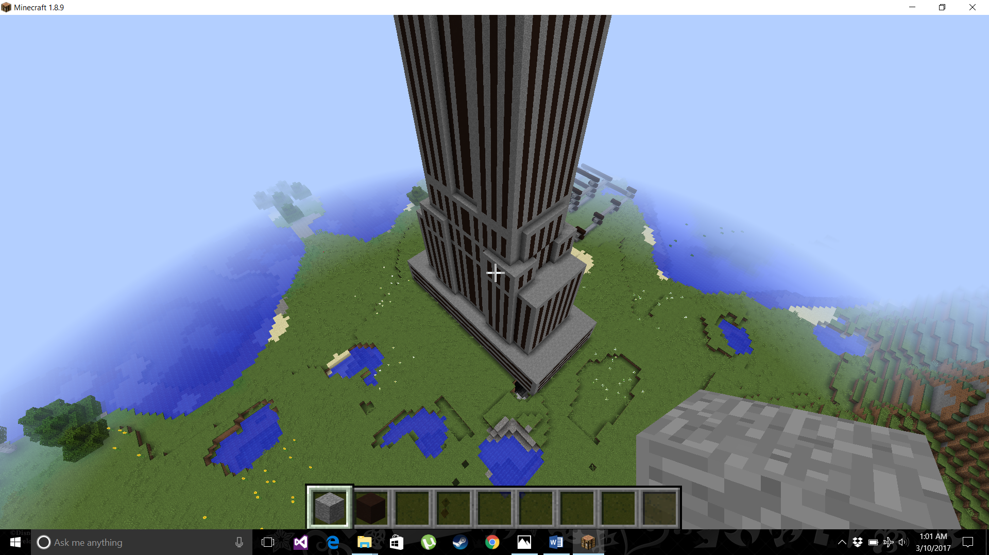



After comparing these pictures, I was confident that with ideal images and more accurate measuring tools I could have near perfect results.

I re-calculated my dimensions as accurately as possible with the limited tools and knowledge that I have. I made sure all the heights added up to 1454’ as they should, and I made sure each layer fit perfectly onto the previous layer. For example, I made sure the floorplan for floors 6-20 fit perfectly onto the floorplan for floors 1-5. I drew most of my floorplans by hand. This made it easier to determine what calculations to make by having a visualization of the structure. I included these drawings at the end of the document.

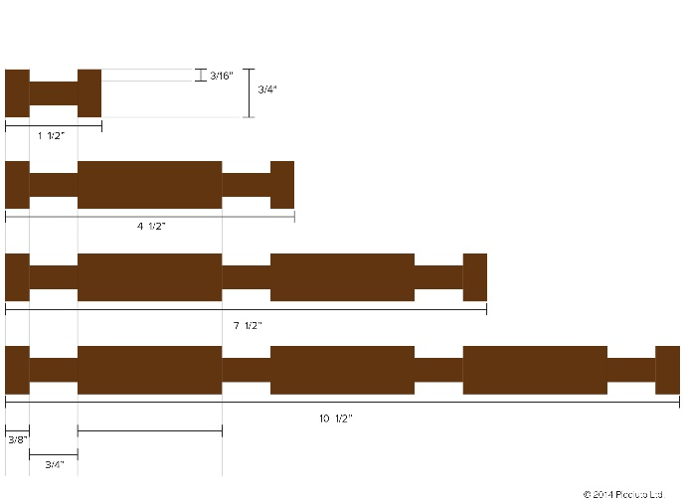**Calculating the Smallest Lincoln Log “Unit”**

After I completed calculating the dimensions of the empire state building I needed to determine the dimensions of the Lincoln Logs when they connect to each other. I needed to understand how Lincoln Logs connect to do this.

I decided to create the smallest possible connected “Unit” with the Lincoln Logs because this would require using more Lincoln Logs in the model. I thought that using more Lincoln Logs would help

provide the needed support for such a massive

structure.

Since I was trying to create the smallest connected Unit of Lincoln Logs I decided to only use the 4.5” logs and the 1.5” logs. I ended up creating a connectable Unit using 12 of these logs. I came up with the design in Minecraft. The image of the connectable Unit represented in Minecraft is shown below.

**\*\*\* From now on I will refer to this configuration of Lincoln Logs as the Unit. \*\*\***

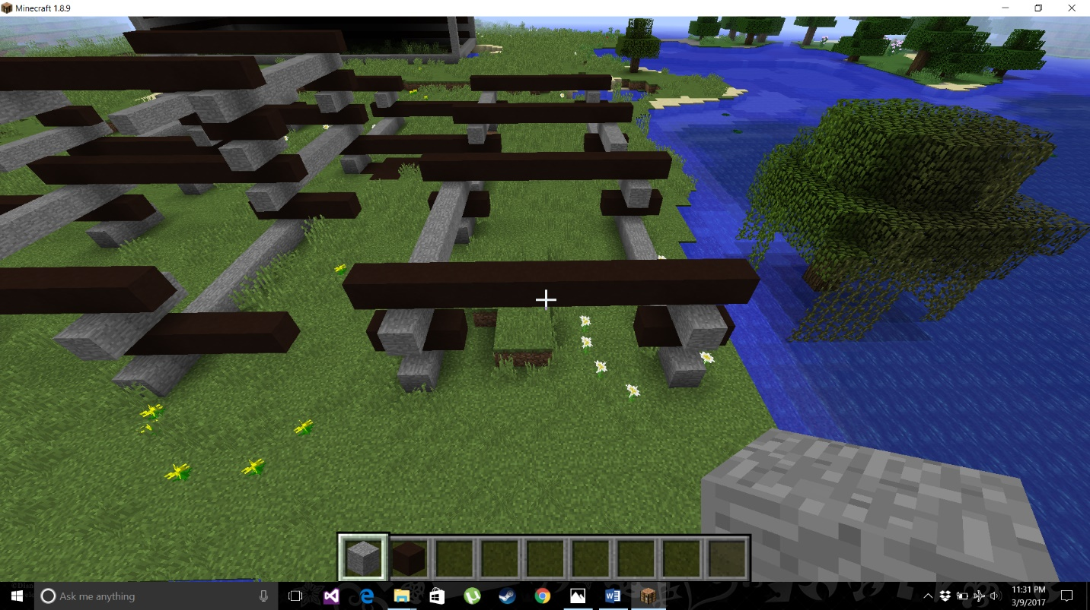The Unit contains four 4.5” logs and eight 1.5” logs.

I designed the Unit so that by rotating the Unit block appropriately it can be connected to an infinite number of Units in any direction. When a new Unit is connected to another Unit the number of additionally required Lincoln Logs depends on how many corners are going to be shared with adjacent Units. This occurs because some of the logs will be shared between the new Unit and the adjacent Units by swapping out 1.5” logs with 4.5” logs to connect the new Unit to the adjacent Units. For vertical connections, I connected the exact same Unit configurations on top of each other. Thus, a vertical connection always takes 12 Lincoln Logs. The numbers of new logs needed relative to the number of shared adjacent corners are given below.

**Horizontal**

1 adjacent corner => 8 new logs

2 adjacent corners => 5 new logs

3 adjacent corners => 2 new logs

4 adjacent corners => 0 new logs (Logs are simply swapped to form a Unit in the middle)

**Vertical**

12 new logs when connecting vertically

**Horizontal Connections of Units:**

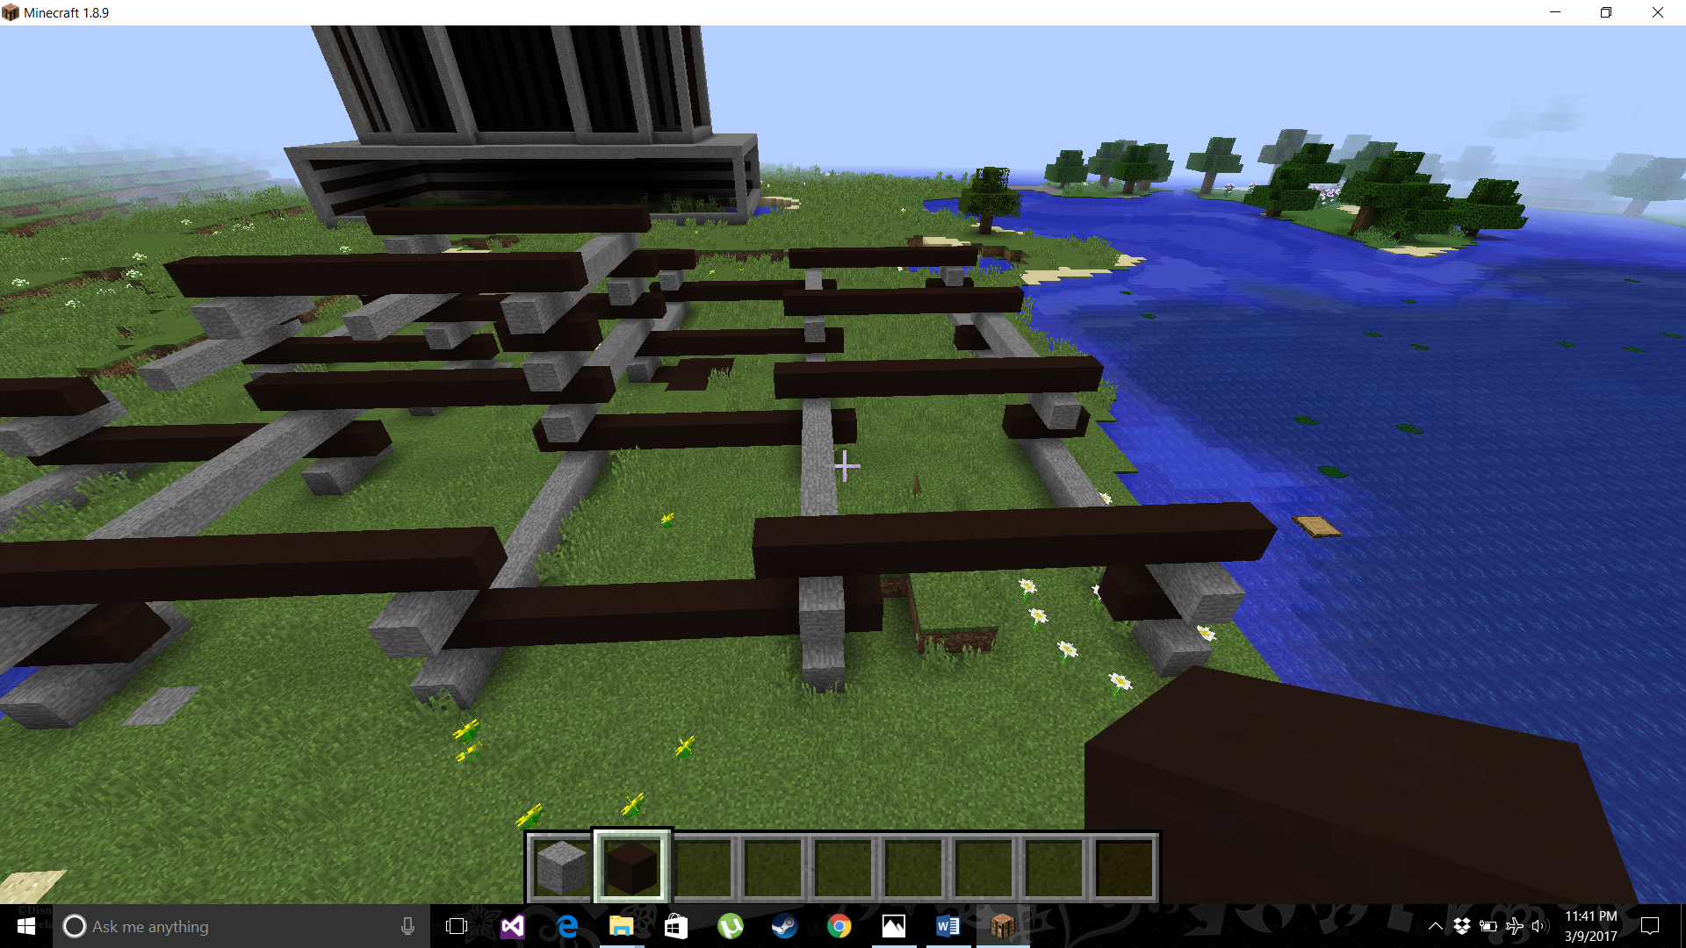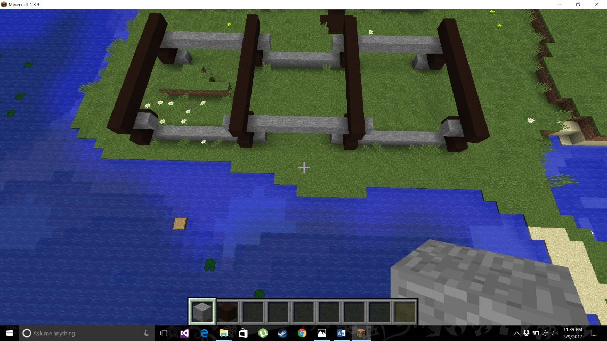

**Vertical Connection of Units:**

*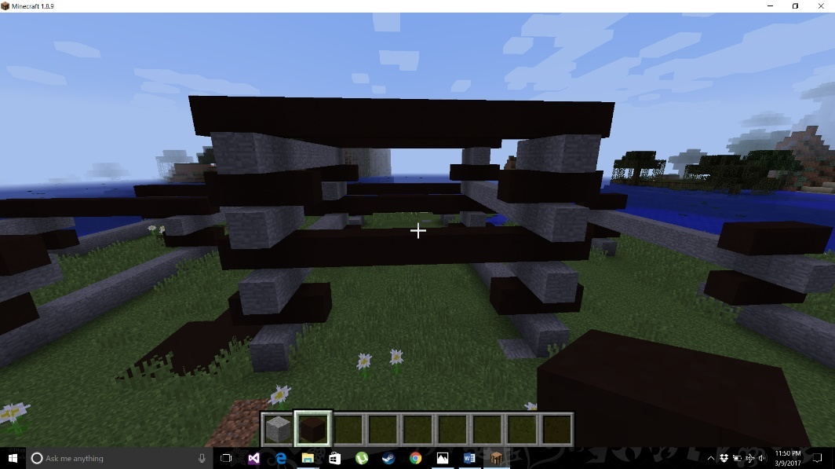If we have a group of horizontally connected Units we could easily stack the exact same structure on top of it. This was a very useful trait for my calculations.*

At this point I began calculating the dimensions of a single Unit.

When I calculated the height of the Unit it was important to consider the height loss when connecting Lincoln Logs. My Minecraft model **DOES NOT** demonstrate the height loss when stacking Lincoln Logs. The amount of height loss per Lincoln Log connection is 3/16” from the log on the bottom and 3/16” from the log on top. Since a Unit has 3 Lincoln Log connections, this would result in a height loss of 3/16” * 2 * 3, or .1875” * 6.

The width calculation of a Unit is trivial. It is simply the width of the 4.5” Log.

**Unit height: .75” * 4 - .1875” * 6 = 1.875”**

**Unit width: 4.5”**

**Unit length: 4.5”**

To determine the added width when connecting Units horizontally we need to consider that when a new Unit connects to an adjacent Unit some width is lost. This results from the Units not connecting edge by edge and consequently overlapping with each other. The connection point is 3/8” inside a Lincoln Log. The width of the actual connection point, 3/4", is also lost in a horizontal connection. Finally, another 3/8” is lost due to the boundary of the adjacent Unit overlapping with the new Unit past the connection point. This results in an increase of 3” instead of 4.5” when connecting Units horizontally. The calculation below was done by subtracting the overlapping lengths from the width of a Unit.

**Horizontal Connection Width Increase = UnitWidth -3/8- 3/4 -3/8 = 4.5 -.375 -.75 -.375 = 3”**

Finally, since stacking Units vertically simply replicates the Unit below it, it would seem like the height would double when stacking two Units vertically. However, this is not the case. When stacking a Unit on top of another Unit 4 Lincoln Log connections are made instead of the only 3 connections when creating a Unit. Therefore, there is an unaccounted for 3/16” + 3/16” of height loss when stacking a Unit vertically.

**Vertical Connection Height Increase = Unit Height -3/16” -3/16” = 1.875 -.1875*2 = 1.5”**

**Calculations**

With the dimensions of the empire state building and the Unit I can now calculate how many Lincoln Logs are needed to create my model.

Given the nature of the Unit all I need to do is calculate how many Units are needed to recreate each unique floorplan (floors 1-5, 6-20,21-24 etc.) and then stack each of these unique structures of Units on top of each other to the appropriate height. In the final step I determine how many Lincoln Logs are in each of these unique stacked structures and sum each of these values together for the total amount of Lincoln Logs needed for the entire model.

For example, consider the base of the empire state building. It is a simple rectangular prism with dimensions 424’ x 187’ x 73.5’ (width x length x height). First I calculate how many Units fill up the width, length, and height. Afterward I simply use the appropriate properties of Units to determine how many Lincoln Logs are needed to create the structure. Each value is rounded to the nearest Integer.

**Sample Calculation**

Width in Units Length in Units Height in Units

**(424’*12 -4.5)/3 + 1= 1696 Units**  **(187’*12 -4.5)/3 = 747 Units** **(73.5’*12-1.875)/1.5 + 1= 588Units**

Number of Logs Used

**(1*12 + 5*1695 + 5*747 + 2*1695*747) * 588 = (12 + 8475 + 3735 + 2532330) * 588 = 2,544,552 * 588 =**

**1,496,196,576 Logs**

**Width in Units Explained**

The *12 represents a conversion of feet to inches. This is done since Units are measured in inches. Now, recall that the first Unit will add a full 4.5” in width, but connecting additional horizontal Units will only add 3” to the total width. The -4.5 represents the first Unit’s width being subtracted from the total width of 424’. The remaining width will be made in increments of 3”. The division by 3 occurs to determine how many Units make up the width that excludes the 4.5” of the first Unit. Since the 4.5” was excluded from the total width, the + 1 at the end of the calculation is done to add back the ignored Unit to the final total of Units.

**Length in Units Explained**

This calculation is identical to the previous calculation except there is no + 1 at the end. This is because the first Unit in the length will be shared by the first Unit in the width. Think of an L shape. The corner of the L is shared by both sides of the L in the same way the length and width will share their first placed Unit.

**Height in Units Explained**

The reasoning behind this calculation is the same as the width in Units calculation. The only differences are the values. The first placed Unit has a height of 1.875”. Each vertically connected Unit adds 1.5” to the total height.

**Number of Logs Used Explained**

It’s important to remember that everything is rectangular in my model, and that the number of additional logs needed when connecting new Units is dependent on the corners shared by adjacent Units. First, imagine placing one Unit in the upper right corner of the rectangular base. This must result in 12 Lincoln Logs since it is the first Unit. This is represented by the 1*12 in the calculation above. Next, imagine filling the width up with as many Units as needed. The width takes 1696 Units total. Thus, we will connect 1696 – 1 (1695) Units to the first Unit. Each of these Units will share 2 corners with an adjacent Unit. Therefore, these connections will be adding 5 new Lincoln Logs per connection. This is represented by 5*1695. Next, the length needs to be filled with Units. Recall that the length and width will share the first placed Unit. This means that even the first placed Unit in the length will share two corners with an adjacent Unit. So, this adds 5 new Lincoln Logs for every Unit needed to make up the length. This is represented by 5*747. With this L shaped border outside the rectangular base we can now fill in the rest of the area. Each of the remaining Units will share three corners with an adjacent Unit. This means they will only require 2 additional logs. The number of times this will be done is the width-1 times the length. This is represented by 2*747*1695. The sum of all these values gives the number of Lincoln Logs in the rectangular base. Thus, the final step is to multiply by how many layers of this base we need. This is equivalent to multiplying by the number of Units required to make up the height needed. In this case the number of Units needed is 588. This number is multiplied to the sum at the end of the calculation to get the final answer of 1,496,196,576 Logs

The general formula for this calculation is shown below:

**Lincoln Logs for Rectangular Volume = (1*12.0 + 5*(wU-1) + 5.0*lU + 2.0 * (wU-1.0) * lU) * hU**

The variables wU, lU, and hU are the width, length and height in Units, as calculated previously. I included the general formulas for these 3 variables below where w, l, and h are the width length and height in feet of any rectangular prism:

**wU = round((w * 12.0 - 4.5) / 3.0+1) 🡨 width in Units**

**lU = round(( l * 12.0 - 4.5) / 3.0) 🡨 length in Units**

**hU = round((h * 12.0 - 1.875) / 1.5 + 1) 🡨 height in Units**

I used the formulas above for every unique floorplan of the empire state building. I summed each of the resulting values of Logs to get the total number of Logs to make my entire model of the empire state building.

I wrote a simple C++ program to complete these calculations. I gave the program the needed dimensions for each floor plan in a text file. I will include the code, the input file, the output file, and all the hand drawn sketches and calculated dimensions I used below. In the end my solution for the number of Lincoln Logs needed was 8,836,984,516!

// CodeFoo17Problem2Calculator.cpp : Defines the entry point for the console application.

//

#include "stdafx.h"

#include <iostream>

#include <iomanip>

#include <fstream>

using namespace std;

int main()

{

ifstream dimensionsFile;

fstream blocksFile;

dimensionsFile.open("dimensions.txt", ios::in | ios::out);

if (!dimensionsFile) { cout << "file failed to open " << endl; return 1; }

blocksFile.open("blocks.txt");

if (!blocksFile) { cout << "file failed to open " << endl; return 1; }

double w = 0.0, l = 0.0, h = 0.0, wU=0.0, lU=0.0, hU = 0.0, blocks = 0.0;

unsigned long long totalBlocks = 0LL;

while (dimensionsFile >> w && dimensionsFile >> l && dimensionsFile >> h)

{

wU = round((w * 12.0 - 4.5) / 3.0+1);

lU = round((l * 12.0 - 4.5) / 3.0);

hU = round((h * 12.0 - 1.875) / 1.5 + 1);

blocks = (1*12.0 + 5*(wU-1) + 5.0*lU + 2.0 * (wU-1.0) * lU) * hU;

blocksFile << fixed << setprecision(0) << blocks << endl;

}

dimensionsFile.close();

unsigned long long temp = 0LL;

blocksFile.seekg(0, ios::beg);

while (blocksFile >> temp)

{

cout << "adding" << endl;

totalBlocks += temp;

cout << totalBlocks << endl;

}

blocksFile.clear();

blocksFile << totalBlocks;

blocksFile.close();

return 0;

}

//InputFile dimensions.txt

424 187 73.5

44 134.2 177.5

75 166.2 177.5

93 134.2 177.5

75 166.2 177.5

44 134.2 177.5

55.4 3 49.5

55.4 3 49.5

72 166.2 49.5

93 134.2 49.5

72 166.2 49.5

55.4 3 49.5

55.4 3 49.5

20.5 92.4 63

196 134.2 63

20.5 92.4 63

71 134.2 502.5

54 102.4 502.5

71 134.2 502.5

60.7 124 108

64.2 53.96 108

60.7 124 108

102.2 163.9 59

97.2 158.9 17

67.2 128.9 14

70 64 7

70 3 14

15 67.2 7

15 67.2 7

65 65 7

20 67.2 7

20 67.2 7

60 60 7

50 50 7

30 30 141

15 15 17

12 12 68

6 6 56

3 3 80

3 14.5 15.4

3 10.36 15.4

3 7.4 15.4

3 2.11 7.7

//OutputFile blocks.txt

1496196576

270953040

569840320

570147040

569840320

270953040

2378772

2378772

152588304

158998752

152588304

2378772

2378772

31183992

425583648

31183992

1233786240

717839340

1233786240

209331648

96333408

209331648

253781656

67433288

31180016

8118432

851200

1856288

1856288

7658784

2459968

2459968

6532064

4547424

33303072

1028704

2665600

582400

232960

197538

141081

101229

15616

8836984516 🡨 sum of all the above numbers

